Name:
Dawood Sarfraz

Roll no:
20p-0153

Section:
BSCS-9A

Assignment no:
UI/UX

Submitted to:
Dr. Omer Usman Khan

Task 1: UI Pathways
Design a Figjam file that reflects UI pathways for your final year project. If you have multiple UI pathways, choose a single one to present your case.

1) Use Case File

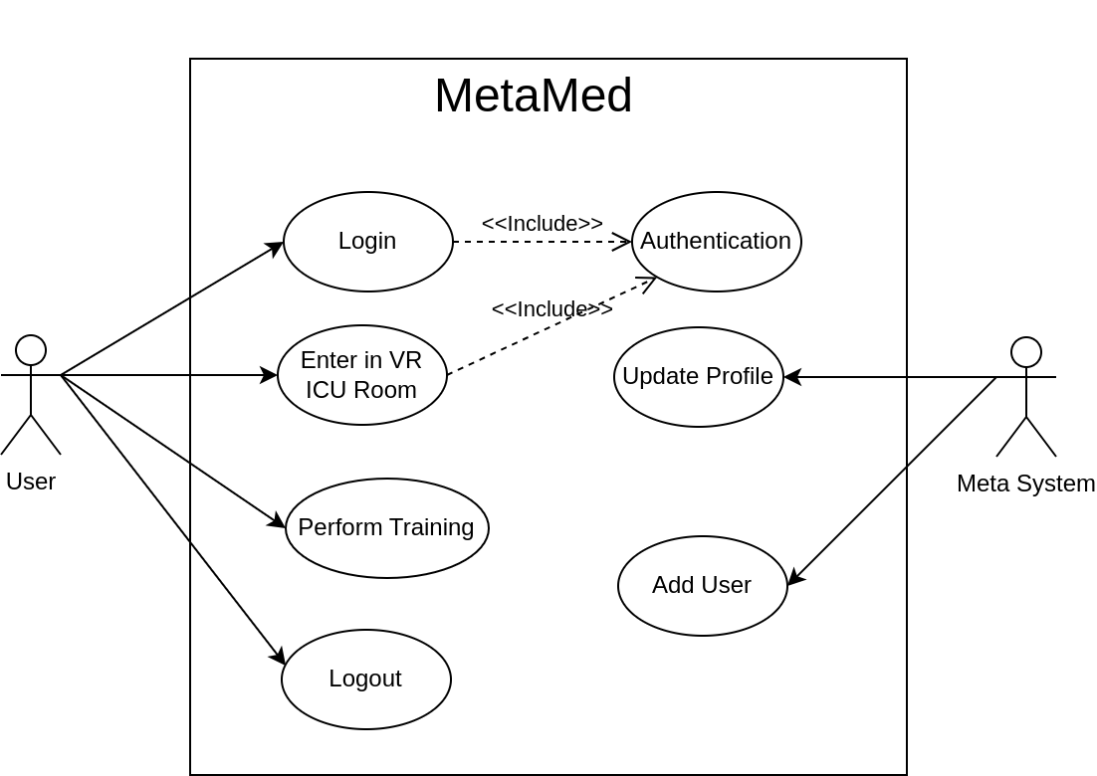
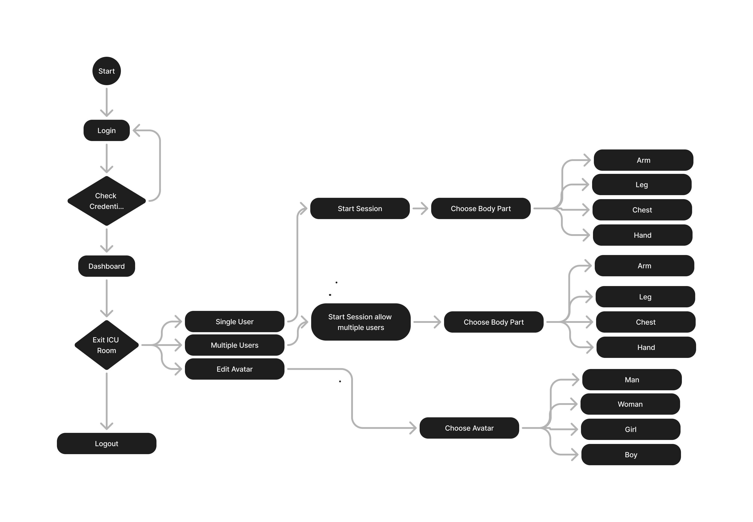
2) Figjam File:

Task 2: User Persona
Depending on who is going to use your product, create some user personas. Explain what demographics you have chosen to describe the personas and why?

1) Personas for MetMed
Persona 1: Sarah, 28 years old
- Occupation:
  - Nurse
- Tech Savviness:
  - Intermediate
- Needs:
  - Quick access to patient management tools and secure login/logout functions for shift-based work.
- Pain Points:
  - Limited time for lengthy processes and a need for reliable, error-free systems.
- Goals:
  - Efficiently manage patient data and access medical records without delay.
Persona 2: John, 45 years old
- Occupation:
  - Student
- Tech Savviness:
  - Low
- Needs:
  - Easy account creation, password recovery, and straightforward navigation for accessing medical history and medication schedules.

- Pain Points:
  - Frustration with complex interfaces and frequent issues with forgotten passwords.
- Goals:
  - Manage his health with minimal hassle, receiving timely reminders and updates.

2) Explanation of Demographics
Age:
The personas range from young adults to middle-aged individuals to cover different stages of life where medical needs vary. Younger healthcare workers prioritize efficiency, while older patients may focus more on ease of use and accessibility.
Occupation:
Occupations are chosen based on the likelihood of interaction with the MetMed app. Healthcare workers need to manage patient data efficiently, patients require easy access to personal health records, and caregivers need tools that allow them to manage multiple accounts.
Tech Savviness:
The personas have varying levels of tech proficiency to ensure the app's usability across different user groups. This diversity highlights the importance of a user-friendly interface that caters to both tech-savvy and less tech-savvy users.
Needs and Pain Points:
Each persona's needs and pain points are derived from their roles and experiences, focusing on usability, security, and efficiency. This helps tailor the MetMed app to meet the specific challenges faced by each user type, ensuring a more personalized and effective user experience.
# Persona 2 for Advance users:
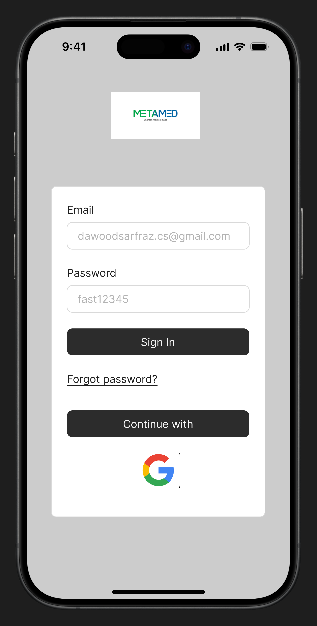 |  | 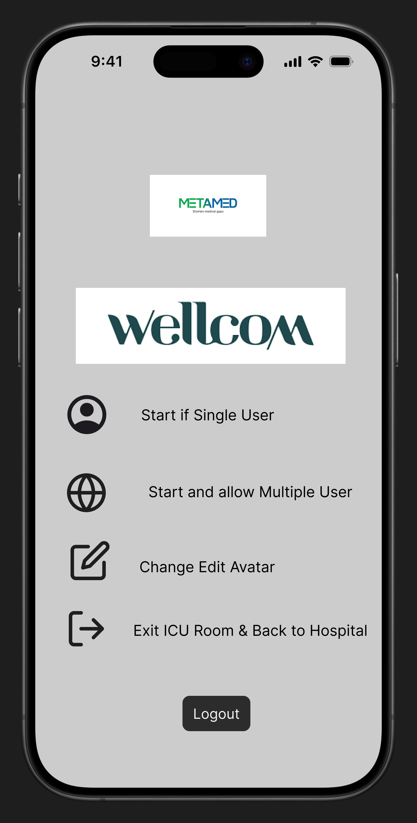

# Persona 2 for Advance users

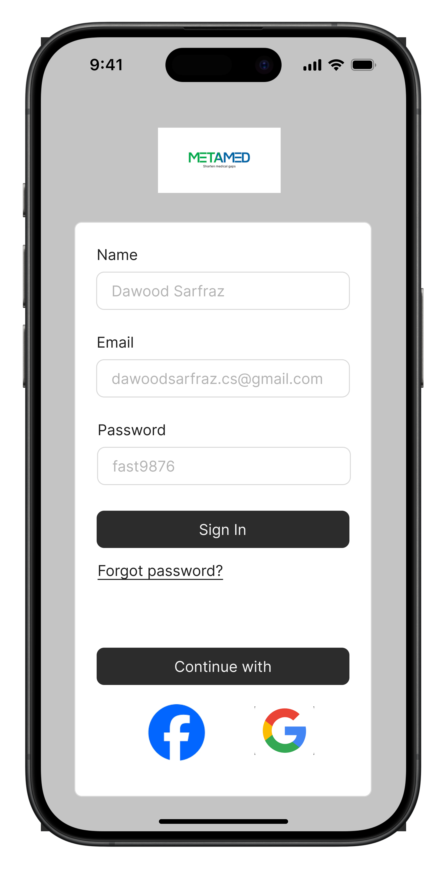 | 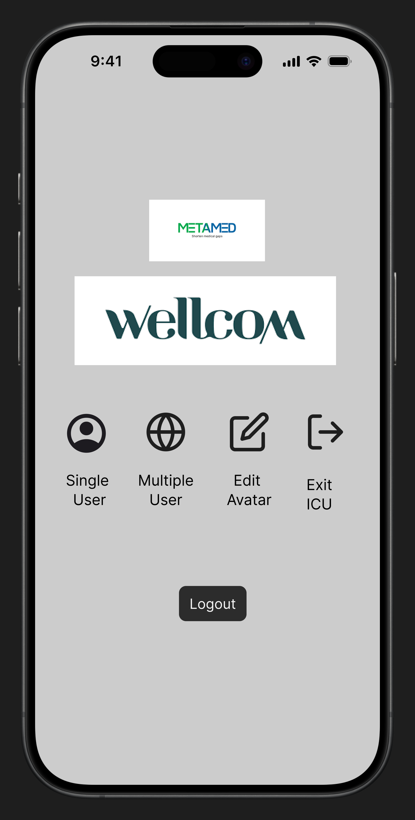

Task 3: Wireframing

Design wireframes (of at least two different fidelity types) for your chosen UI pathway. One of the wireframe must contain a complex design. Use Figma for the purpose.

1) Wire-frame:

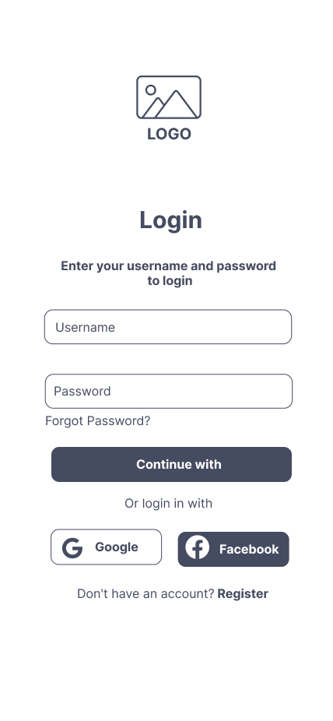 | 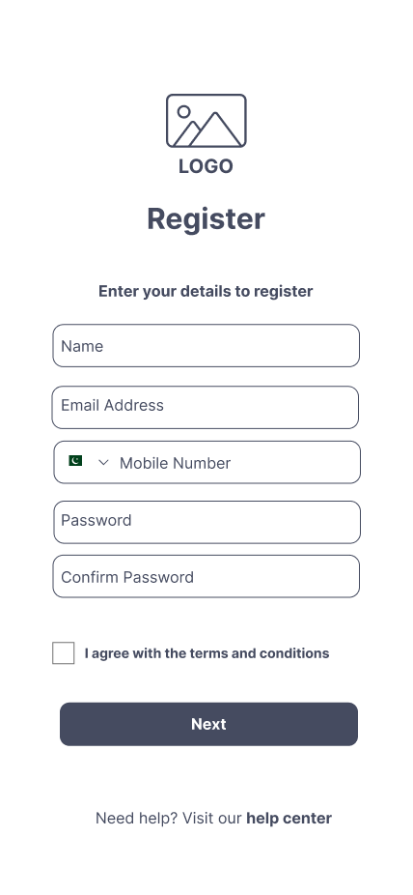 | 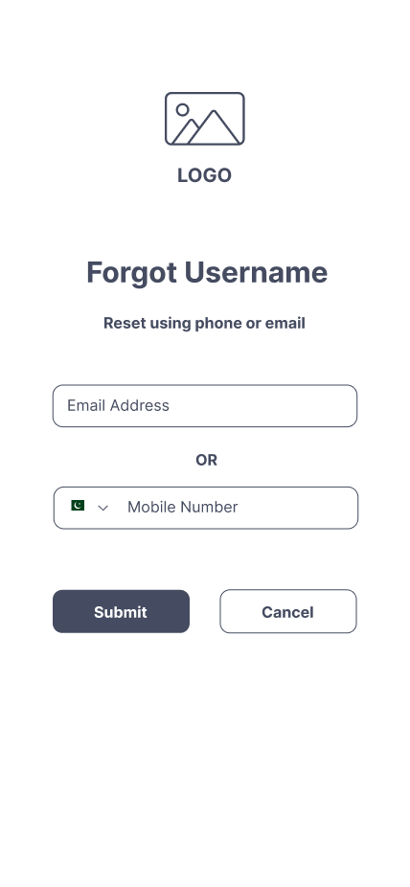
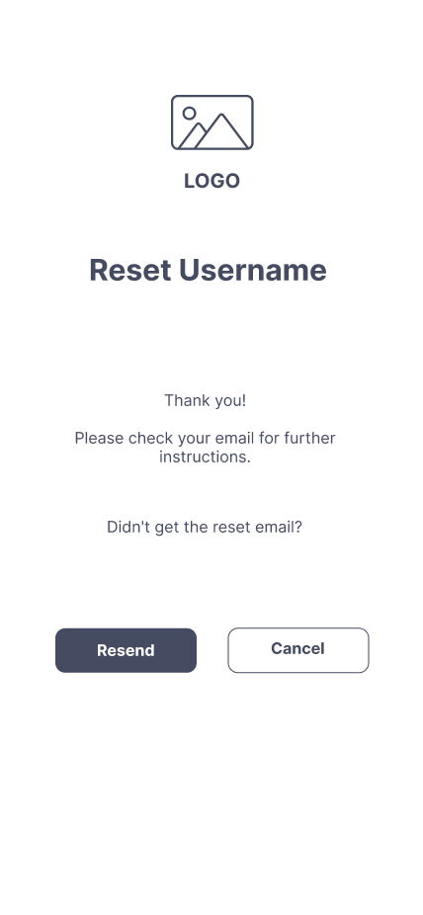 | 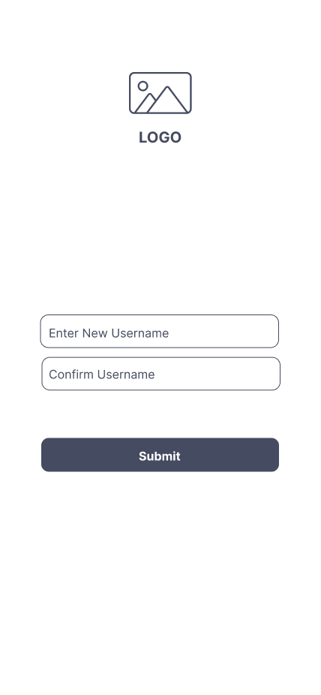 | 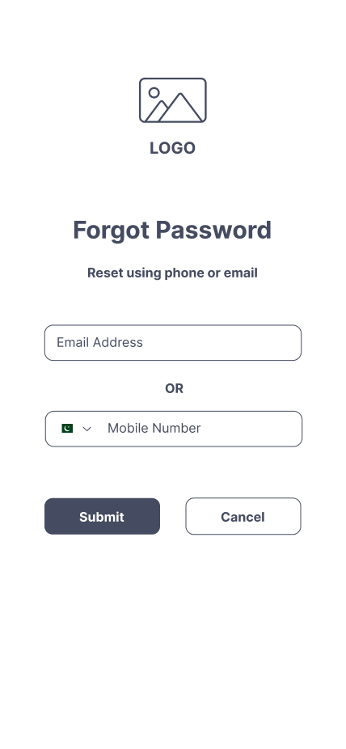
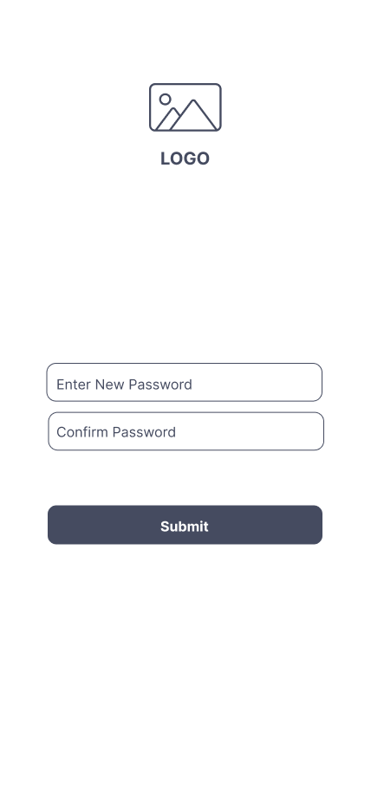 | 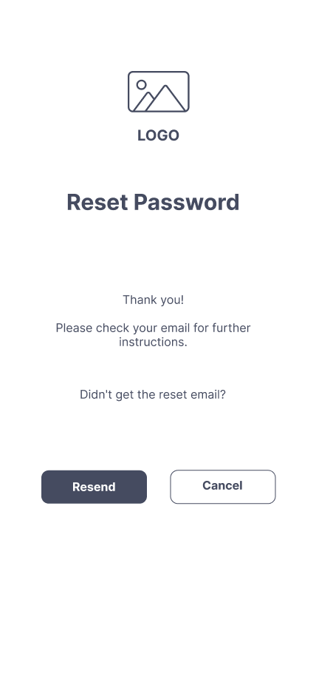 | 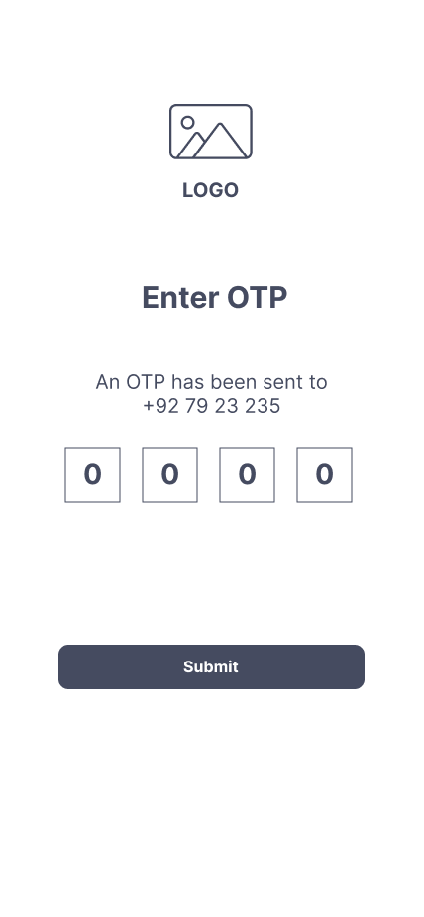
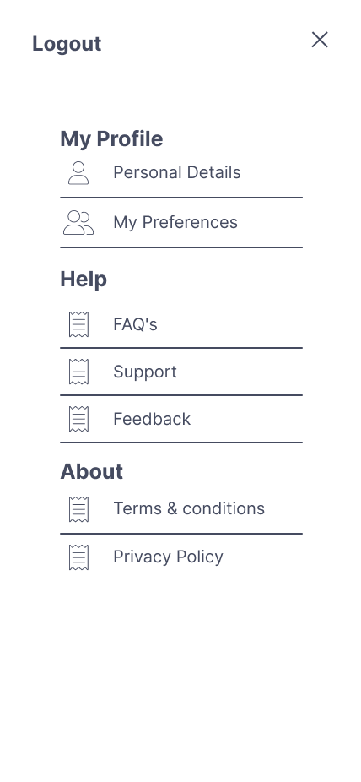 | 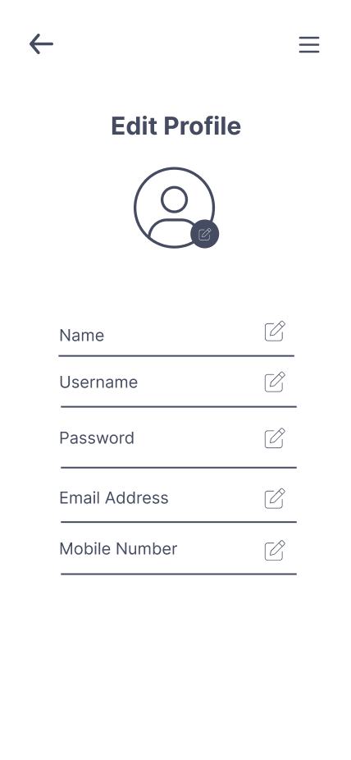 | 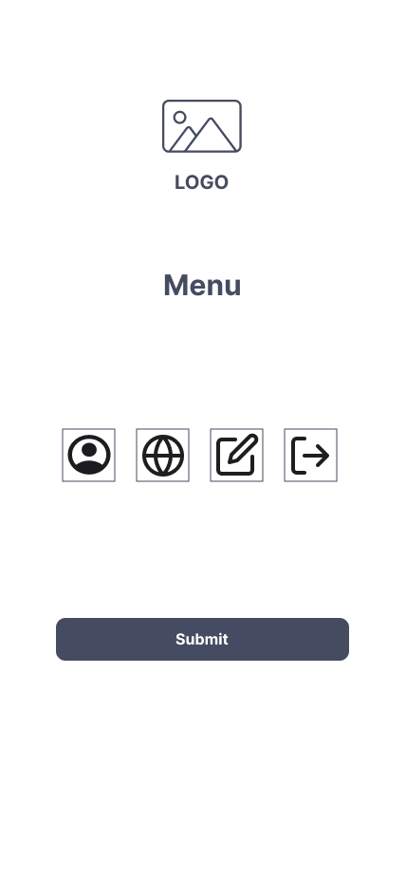
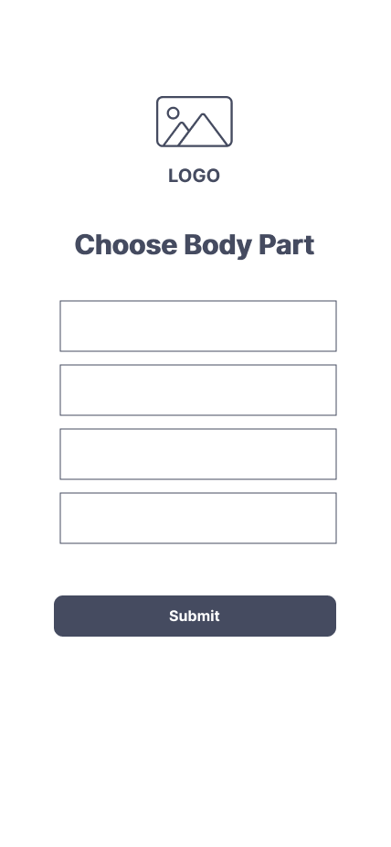 | 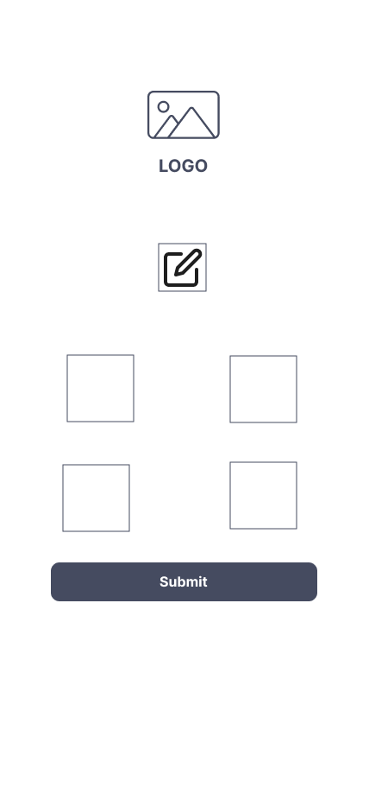 | 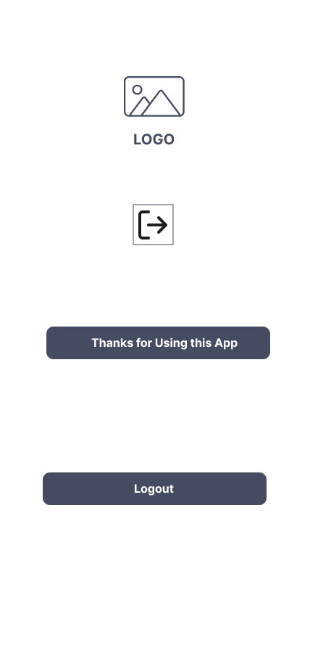
2) Wire-frame 2:

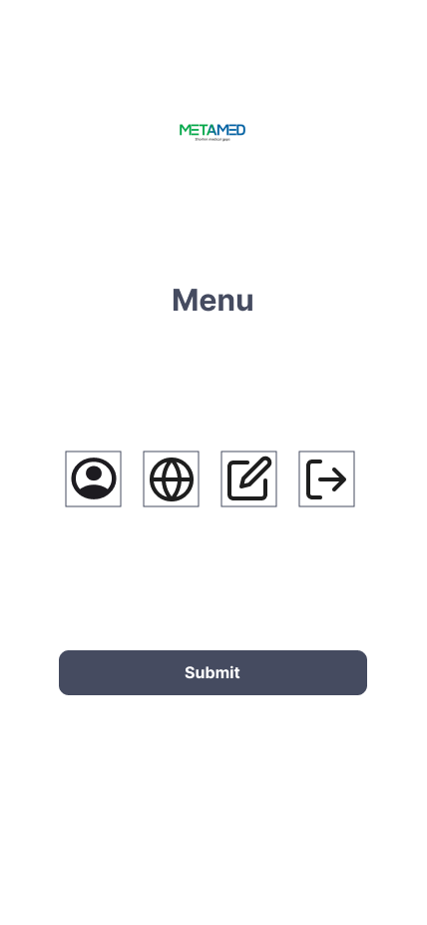 | 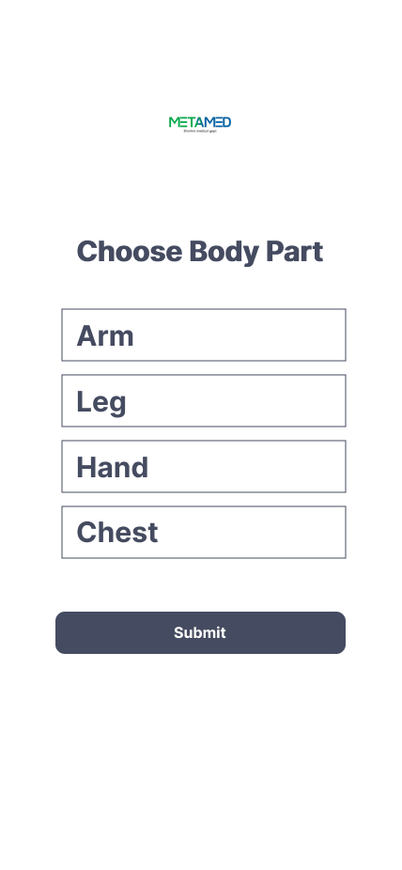 | 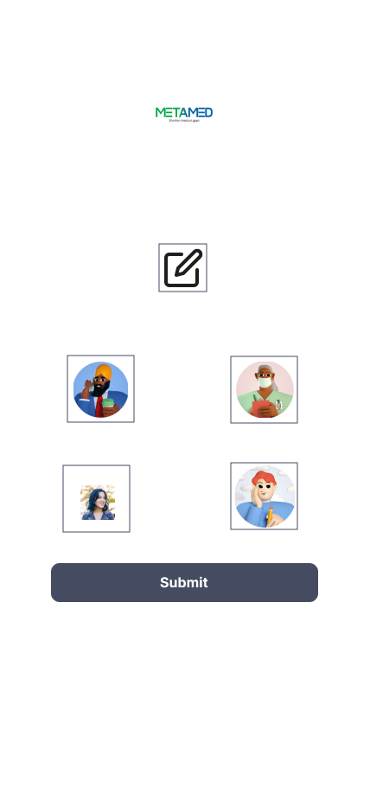
 | 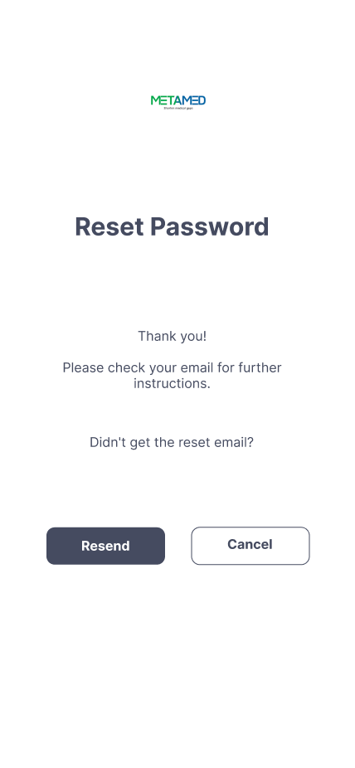 | 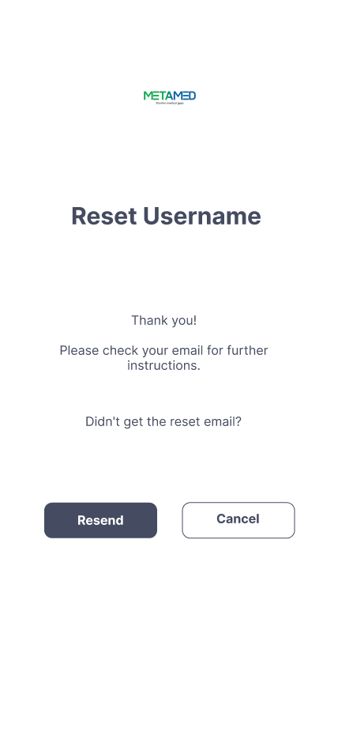
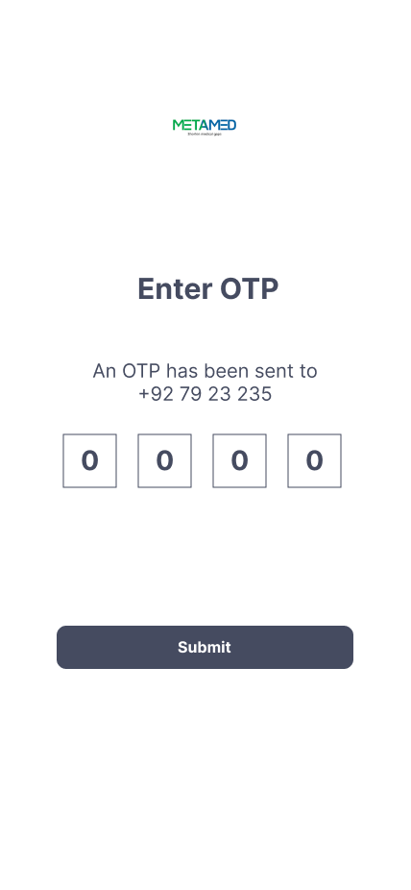 |  | 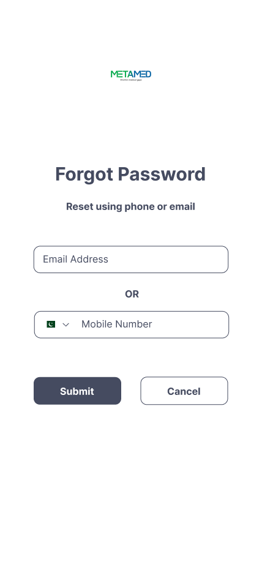
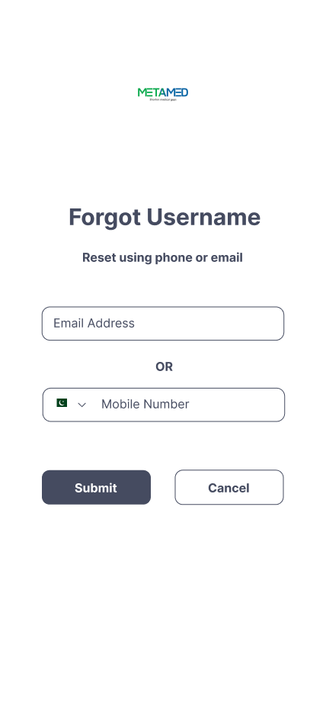 | 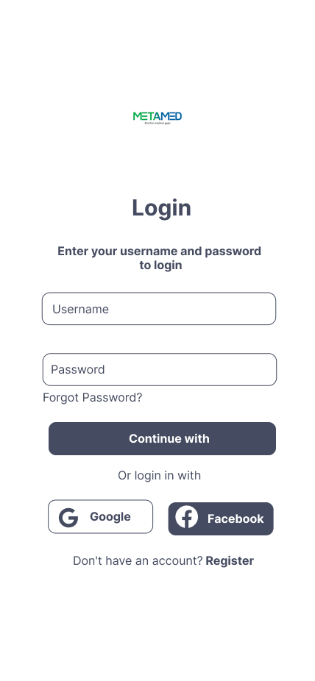 | 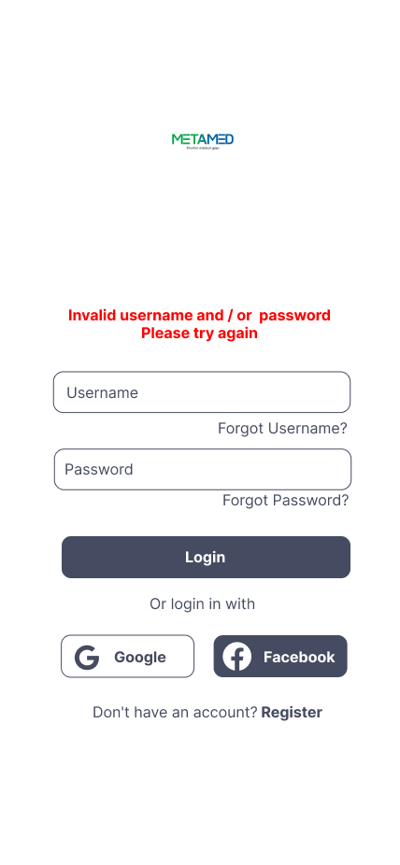
 | 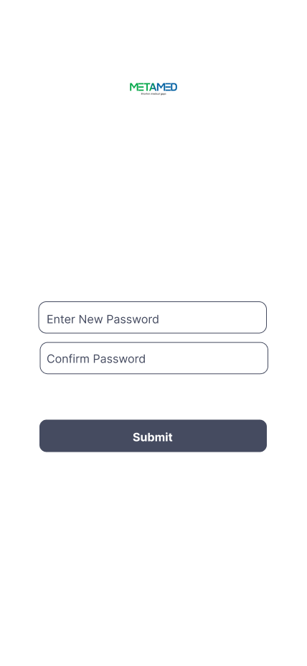 | 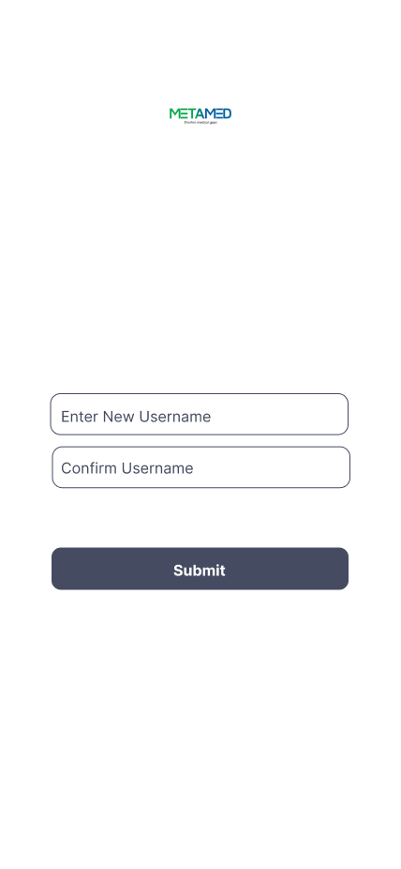
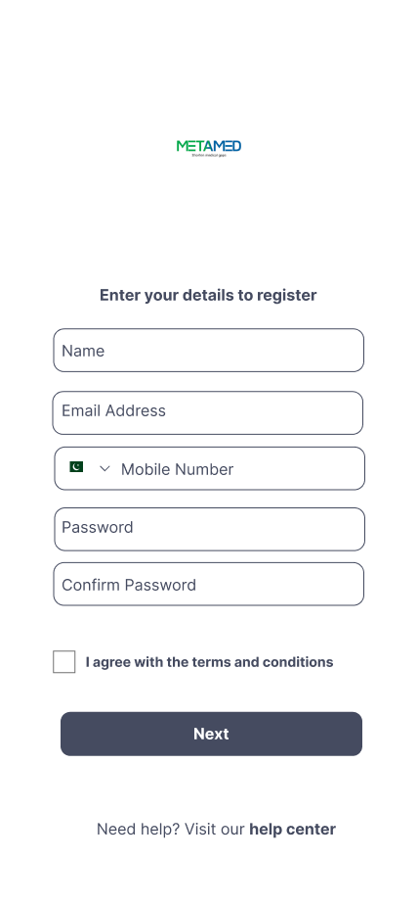 | 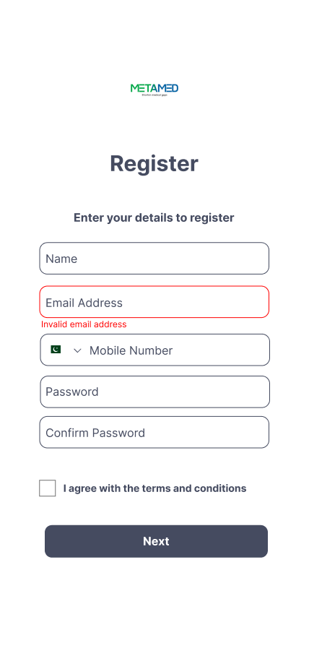 | 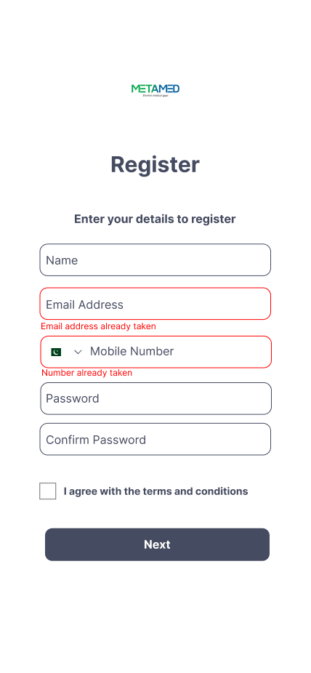
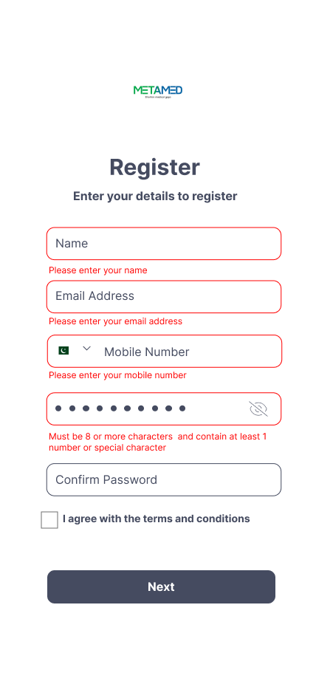 | 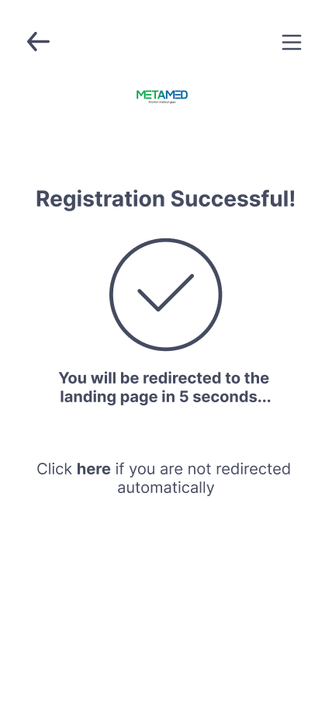 | 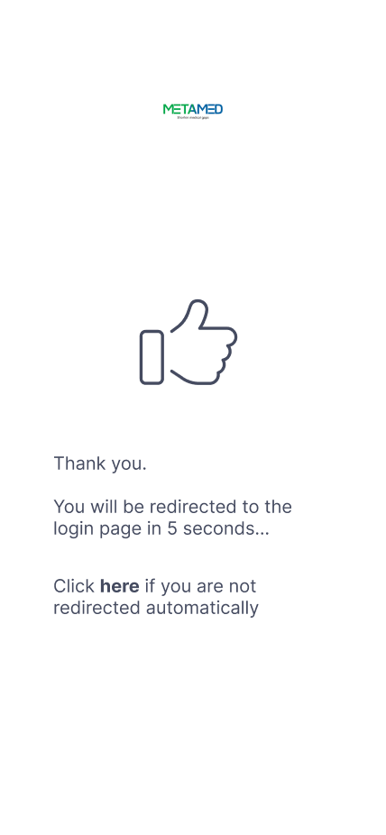
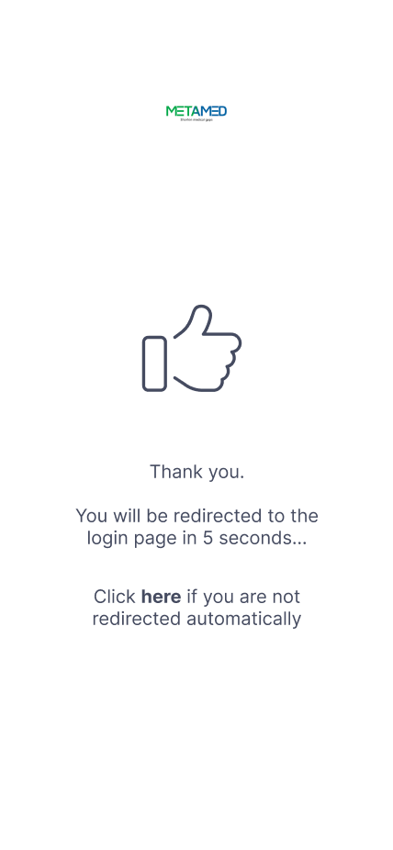

Task 4: Usability Design Discussion
Choose whether you want to follow Nielson’s (1993) or Norman (2002). For the wire-frames you gave, describe in 2-3 sentences how your U-I is satisfying their usability Principles.

How your Meta-Med app U-I satisfies Norman's (2002) usability principles:
- Visibility:
  - Essential actions like login, logout, and account creation are prominently displayed on the main screens, making them easy to locate.
  - Distinct icons and labels ensure users can quickly identify and select the necessary actions.
- Feedback:
  - The app provides immediate feedback, such as a loading spinner or success/error messages after actions like login.
  - Users receive confirmation messages when an OTP is sent, guiding them on the next steps.
- Affordance:
  - Interactive elements like buttons and text fields follow familiar standards, making it clear what actions are possible.
  - Placeholder text in input fields guides users on the required information.
- Mapping:
  - Controls are logically placed, with options like "Reset Password" near the login area, making navigation intuitive.
  - Buttons lead directly to the expected screens, aligning with user expectations.
- Consistency:
  - The app maintains a consistent design language, with uniform colors, fonts, and button styles across all screens.
  - Similar functions are represented consistently, helping users build a reliable mental model.
- Constraints:
  - The UI uses constraints to prevent errors, such as disabling the "Submit" button until all required fields are filled out.
  - Input constraints, like a minimum character count for passwords, reduce the likelihood of user mistakes.

Task 5: UI
Design your UI in Figma and export it to tkinter. The UI must reflect your chosen highest fidelity wireframe.

Task 6: A/B Test

Due to scarcity of time, it is okay if you work on just one UI variation for our chosen UI pathway. But you must convert it into a quantitative score. Use any metric discussed in class.
A/B Test Quantitative Score Table
Metric | Description | Score
Learnability | Time taken for new users to complete the login process. | 85/100
Efficiency | Average time to complete the "Create Account" process. | 80/100
Satisfaction | User satisfaction score based on survey (out of 100). | 90/100
Error Rate | Number of errors during the process. | 0 errors
Task Completion Rate | Percentage of users who successfully complete tasks. | 95%
Overall SUS Score | Aggregate usability score (out of 100). | 87/100

Explanation:
- Learnability:
  - Measures how quickly new users can navigate & complete tasks within the app.

- Efficiency:
  - Assesses how fast users can complete the "Create Account" process.

- Satisfaction:
  - Reflects users' overall satisfaction based on feedback.

- Error Rate:
  - Counts the errors encountered during key processes like "Reset Password."

- Task Completion Rate:
  - Percentage of users who successfully complete their intended tasks.

- Overall SUS Score:
  - Combines these metrics into a single usability score.

